

Java Programming
Experiment Report Book

Year & Semester 2024-2025-2
Major & Class 23计科全英
Name 代翔
Student No. 2023337621159
Phone No. 15700145894
Teacher 吴婷婷

6/2025

目 录
1 目 录 1
1 Experiment 5 Animation – Display a running fan 1
1.1 Purpose 1
1.2 Task 1
1.2.1 Program 1
1.2.2 Requirements 2
1.3 Experiment Report Template 2

Experiment 5 Animation – Display a running fan

Purpose
1. Learn to develop UI using JavaFX.
2. Master layout panes, setting style for control components, event handling (including ActionEvent, MouseEvent, and KeyEvent), and Timeline animation.

Task

Program
Write a program that displays a running fan. Use the > and || buttons to start and pause fan running. Use the ← and → buttons to left reverse and right reverse fan running. Use the ↑ and ↓ buttons to increase and decrease speed of fan running. Use animation to show the current time no matter fan is running or paused. Also control fan running with MouseEvent and KeyEvent.
The initial status and paused status is shown in Figure 1. The running status is shown in Figure 2.
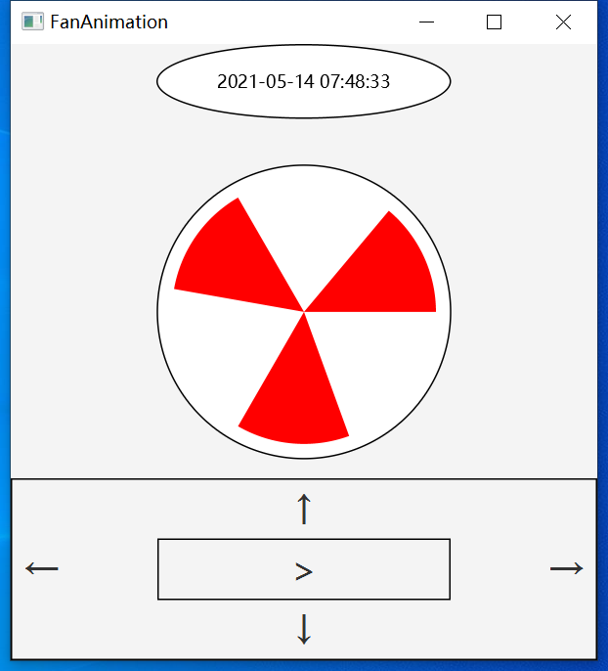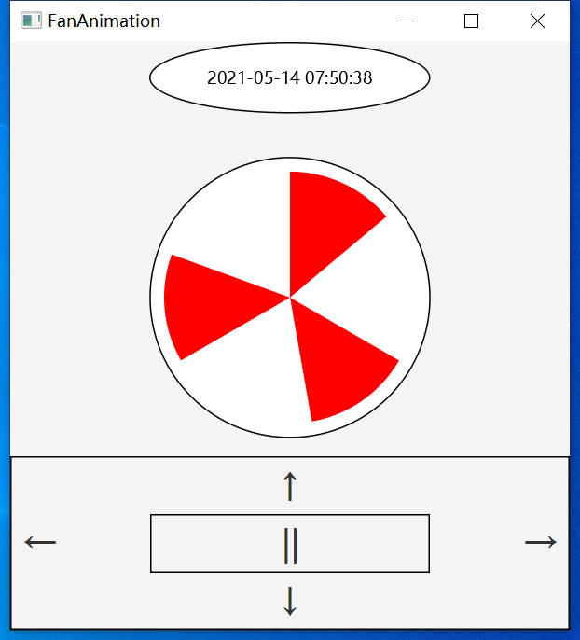
Figure 1 The initial and paused status Figure 2 The running status

Requirements
- Define three classes
Define TimePane class, FanPane class, FanAnimation class to (1) display animation of the current time, (2) display fan running animation, and (3) control fan running using buttons.
- ActionEvent on buttons
- When cursor is on the button, change cursor into hand;
- Click > button to start fan running;
- Click || button to pause fan running;
- Click ← button to make fan running turn left;
- Click → button to make fan running turn right;
- Click ↑ button to speed up fan running;
- Click ↓ button to speed down fan running;
- MouseEvent on fan
Click mouse on the fan to change its current status. For example,
- If the fan is running and click mouse on the fan, change it into paused;
- If the fan is paused and click mouse on the fan, change it into running;
- KeyEvent on FanPane
- Press Enter on keyboard to start and pause fan running;
- Press Up on keyboard to speed up fan running;
- Press Down on keyboard to speed up fan running;
- Binding properties
- Bind the position of the fan to its outer pane properties. So that no matter how we change the window’s size, the position of fan is always in the center of the window.

Experiment Report Template
Experiment 5 Animation – Display a running fan

Course: Java Programming 2024-2025-2
Name: 代翔 Student No.: 2023337621159 Class: 23计科全英
Date: 2025 / 6 / 6 Lesson: 6-8，Address: 10-409

NOTE：
1. Fill in the name, student No., class, and date.
2. Name the report as “studentNo_Name_Experiment5.doc”. For example, “12345678_zhangshanshan_Experiment5.doc”. Otherwise, the report will be refused.
3. Submit the report and code in a compression package in Chaoxing.

- Experimental Purpose
Refer to the handbook

- Experimental Task
Refer to the handbook

- Experimental Process Record and Result
Class Structure:​​
Created TimePane class using Canvas with Timeline animation to display real-time clock
Implemented FanPane class extending Pane to draw fan blades and handle positioning
Developed FanAnimation controller class for event binding and state management
Animation Logic:​​
// Fan rotation animation
Timeline fanTimeline = new Timeline(
new KeyFrame(Duration.millis(10), e -> rotateFan())
);
fanTimeline.setCycleCount(Timeline.INDEFINITE);
Used RotateTransition for blade movement with adjustable rate property for speed control
Implemented bidirectional binding for fan center position:
centerXProperty().bind(widthProperty().divide(2))
​​Event Handling:​​
// Keyboard controls
setOnKeyPressed(e -> {
if (e.getCode() == KeyCode.ENTER) toggleRunning();
if (e.getCode() == KeyCode.UP) increaseSpeed();
});

// Mouse click on fan
setOnMouseClicked(e -> toggleRunning());
Button handlers with visual feedback using setCursor(Cursor.HAND)
Implemented acceleration/deceleration logic with speed clamping (0-1000 rpm)
UI Components:​​
Designed control panel with SVG-style buttons
Responsive layout using BorderPane with fan/time centered
Test Results:​​
Initial State:​​
Fan blades stationary at 0° position
Digital clock displaying current time
Control buttons enabled except pause
Functionality Verification:​​
​​Boundary Cases:​​
Maximum speed (1000 rpm): Blade animation becomes near-continuous
Window resize: Fan remains centered with proportional scaling
Speed decrement at 0 rpm: Disables ↓ button (setDisable(true))
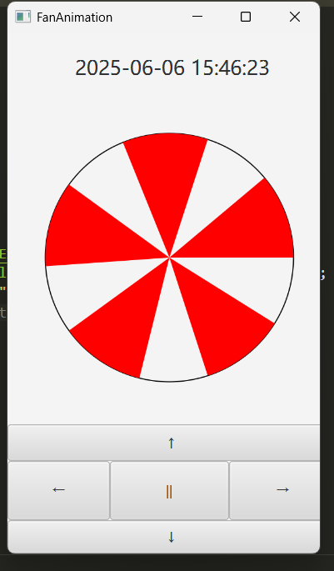
- Experimental Experience
  - Summary
The purpose of this experiment is to master JavaFX animation techniques through interactive component development. Firstly, understand coordinate transformations by implementing rotational mathematics for fan blades. Secondly, become familiar with event delegation models through multi-input handling (mouse/keyboard/buttons). Thirdly, master property binding by synchronizing UI states with animation parameters. Finally, integrate temporal concepts via real-time clock synchronization with system time.
4.2 Personal Experience
Developing the fan controller revealed fascinating challenges in animation physics. Initially, I struggled with frame-rate consistency when adjusting rotation speeds, but solving this through the Timeline's rate property gave me deeper insight into JavaFX's animation architecture. The most rewarding breakthrough came when implementing bidirectional binding – seeing the fan dynamically reposition itself during window resizing felt like magic!
Unexpectedly, the clock animation proved more complex than anticipated. Synchronizing smooth second-hand movement required using AnimationTimer instead of Timeline for better precision. For future enhancements, I'd add blade shadow effects using DropShadow and implement speed presets. This project transformed my understanding of how mathematical concepts like angular velocity directly translate to visual programming.

